

USER GUIDE

*Programming Project Stage 2*

Jack Carey, IS1101

Table of Contents

[Installation 3](#_Toc520570534)

[Extracting 3](#_Toc520570535)

[Excecuting 4](#_Toc520570536)

[Gameplay 5](#_Toc520570537)

[Starting the game 6](#_Toc520570538)

[Controls 7](#_Toc520570539)

[Power Ups 7](#_Toc520570540)

[Ghosts 8](#_Toc520570541)

[Scoring 8](#_Toc520570542)

[Ending the game 9](#_Toc520570543)

[Troubleshooting 10](#_Toc520570544)

[Notes 11](#_Toc520570545)

# Installation

## Extracting

Installing and running this game is simple. Locate the downloaded .zip file, and extract it to a convenient location on your computer by right clicking on the .zip file, selecting “Extract all”, and following the prompt.

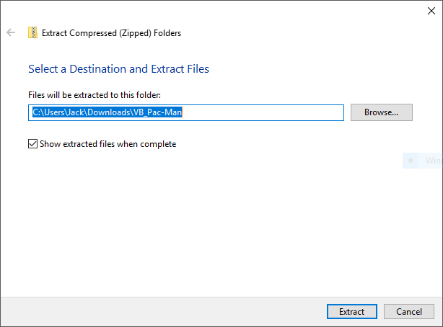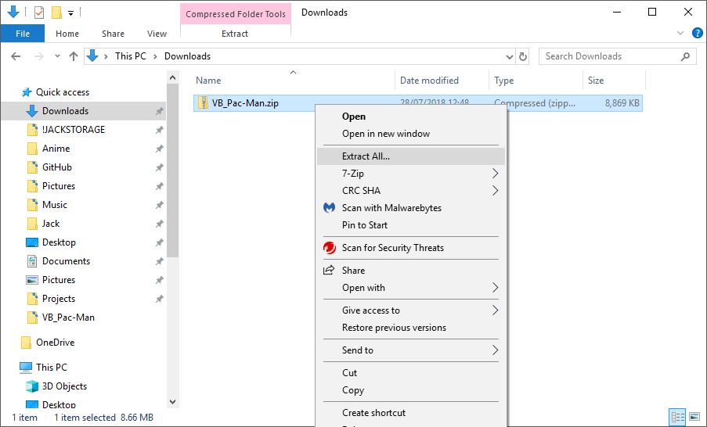

## Excecuting

Open the extracted folder and run the “VB Pac-Man.exe” executable by double clicking on the file. It should be easily recognisable by its icon! If you would like to browse, and possibly assess the code of the game, you can double click on “VB\_Pac-Man.sln”.

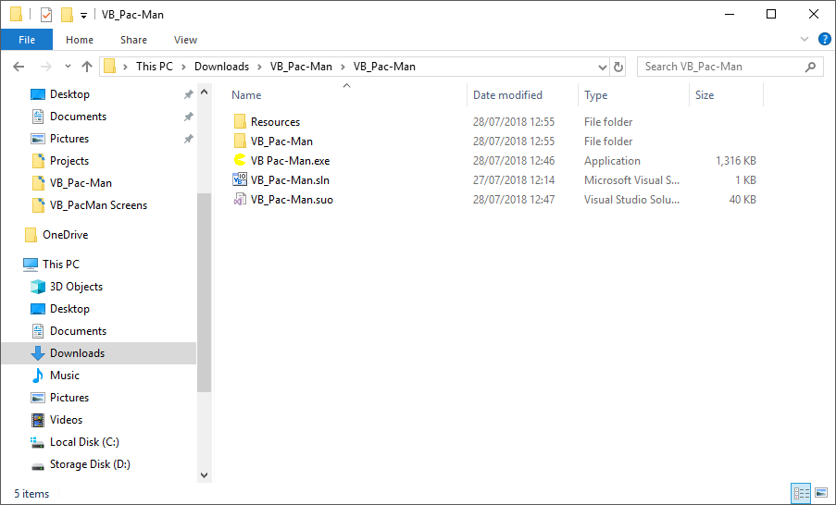

# Gameplay

Pac-Man was originally released in 1980 in Japan, and became an international arcade success, and a classic video game. This is a recreation of this game, attempting to stay as true to the original design and specs as possible.

The aim of the game is to achieve the highest score possible. The developer’s high score is 42,320 points. See if you can beat it! As a player, you must navigate Pac-Man through the maze, collecting as many Pac-Dots and Power Pellets as possible all whilst avoiding the ghosts constantly pursuing you through the maze. Remember, you only start with three lives, so be careful! Collect all the pellets in a maze and you will progress to the next level. Collect 10,000 points and you’ll receive an extra life!

## Starting the game

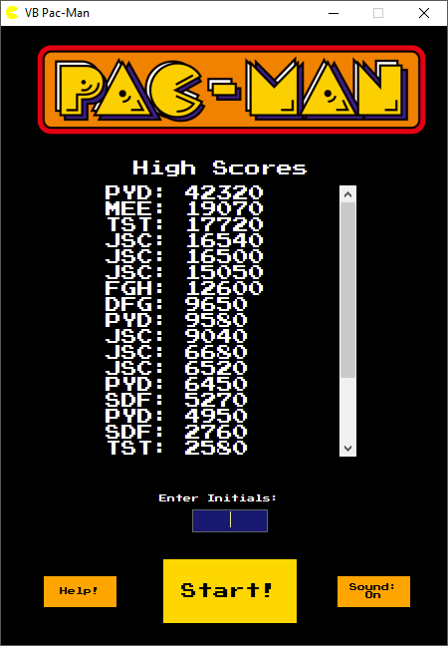After you have opened the executable file, you will be greeted with the following screen. There are a few features on this screen which you should be aware of:



: Click this button for a brief description of the game

: Click this to toggle the game sound effects

This screen also shows the high scores which have been made on the computer you’re playing on. High scores do not sync across computers!

To begin the game, enter your initials, ensuring they are 3

capital letters, and click or press Enter.

## Controls

../../../../Downloads/VB_Pac-Man/Resources/Images/Static_Right.png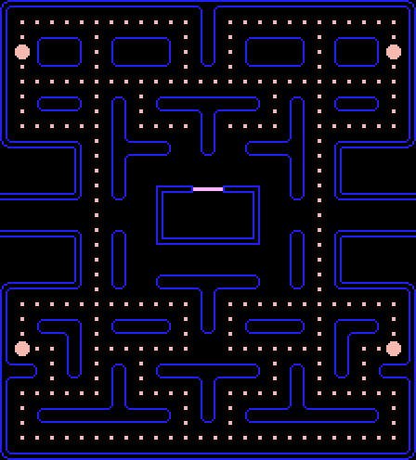Use the arrow keys to move Pac-Man up, down, left, or right respectively. Not you do not need to hold the arrow keys; Pac-Man will move automatically in the direction he is facing. The arrow keys tell Pac-Man to turn in that direction at the next possible opportunity, so, for example, if Pac-Man is travelling right and you press the up arrow, he will turn up at the next intersection.

## Power Ups

../../../../Downloads/VB_Pac-Man/Resources/Images/Blue.gifNear each of the four corners of the map are larger pellets called Power Pellets. If Pac-Man eats these pellets the ghosts temporarily become frightened, turn blue, and scatter randomly. While the ghosts are blue, Pac-Man can eat the ghosts for bonus points. If he eats two ghosts in a row he will receive combo points. Be careful though: the ghosts aren’t dead for ever! They simply return to their starting position and revive.

## Ghosts

There are two ghosts in this version of the game. Blinky: the red ghost, and Pinky, the pink ghost. These ghosts both have their own unique personality to match the AI in the original game. Blinky has the personality of “Shadow”, where they will chase you relentlessly, while Pinky has the personality of “Speedy”, or ambusher, where they will aim to cut off your path of movement. Both ghosts have an amount of time where they scatter, and don’t chase you, giving you a chance to get away and have a breather, before they reverse directions and chase you again. Be careful though! The longer you spend on one level, the more relentless their chasing gets!



## Scoring

|  |  |
| --- | --- |
| ../../../../Downloads/VB_Pac-Man/Resources/Images/Map_w_pellets.png | Pac-Dots. Each dot will net you 10 points |
| ../../../../Downloads/VB_Pac-Man/Resources/Images/Map_w_pellets.png | Power Pellet. This will give 50 points and the opportunity to eat ghosts! |
| ../../../../Downloads/VB_Pac-Man/Resources/Images/400.png | The first ghost you eat in one power-up period will net you 400 points |
| ../../../../Downloads/VB_Pac-Man/Resources/Images/800.png | Eating another ghost in the same power-up period will get you 800 points! |

## Ending the game

Once you have run out of lives, you will see this screen. You will see your initials along with your high score amongst the other high scores. See if you can make it to the top! You can play the game again by pressing “Play Again”.

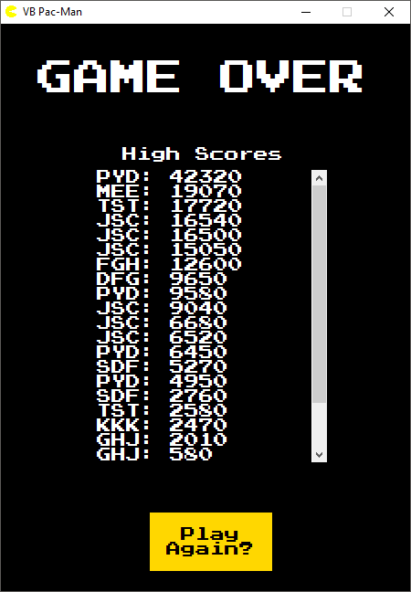At any time, you can press the “X” in the top right hand corner of the screen to close the game, however do note that your high score will not be saved if you close the game before you lose all your lives!

# Troubleshooting

|  |  |
| --- | --- |
| Problem | Resolution |
| **I can’t start the game!** | Ensure that the executable file is extracted from the zip folder before running the game. |
| **The game won’t accept my initials!** | Ensure that the initials you enter are exactly three, uppercase letters with no numbers or symbols |
| **The game crashed and I lost my high score!** | Unfortunately, your high score is not able to be recovered, however if you report the crash details to the developer the problem can be resolved in a future patch. Restart the game by double clicking your executable again. |

# Notes